**MCMCglmm models**

After evaluating VIFs, some models were run with interaction term and some without, as follows:

formula_dev <- Brain ~ Weaning.age + Litter.size + BodyN

formula_soc <- Brain ~ Group.living + Parental.care + Mating.system + Population.density + BodyN

formula_env <- Brain ~ DiurnalityN + Shelter.safety + Arboreality + Diet + HR + BodyN

formula_ori <- Brain ~ Origin * BodyN

formula_vul <- Brain ~ Status * BodyN

formula_tor <- Brain ~ Torpor * BodyN

formula_pla <- Brain ~ Play * BodyN

formula_fmr <- Brain ~ FMR.Riek * BodyN

**Missingness analysis**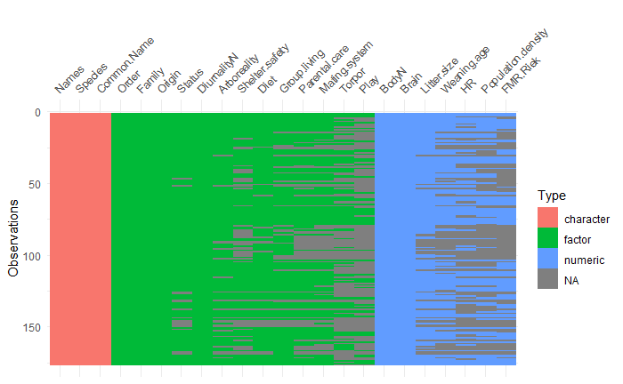

Figure 1a. Pattern of missingness in all variables divided by type of variable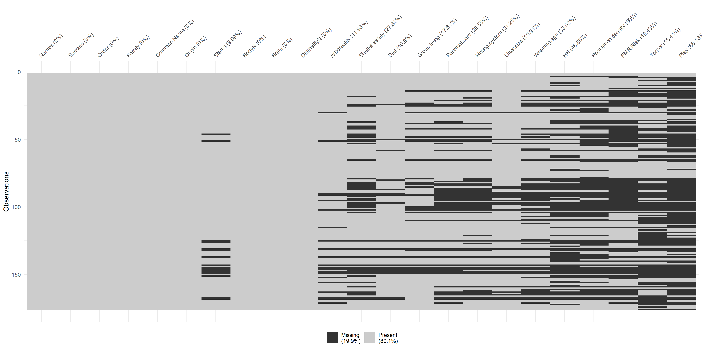

Figure 1b. Pattern of missingness and percentage of missing data per variable

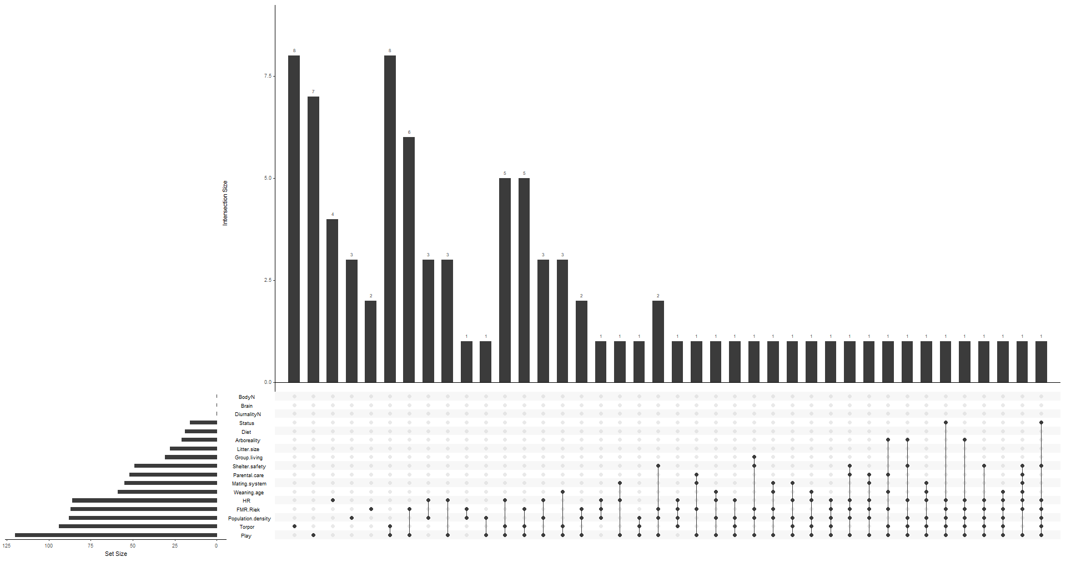

Figure 1c. NA Structure

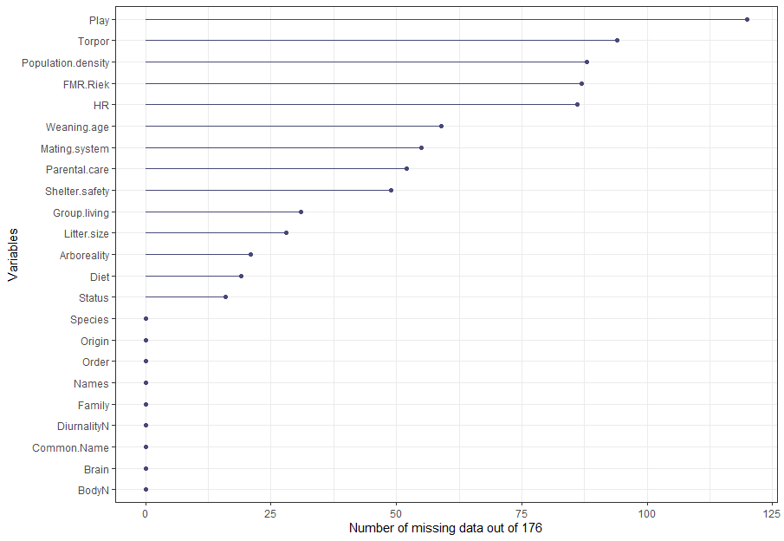

Figure 2. Number of missing data per variable out of 176 cases

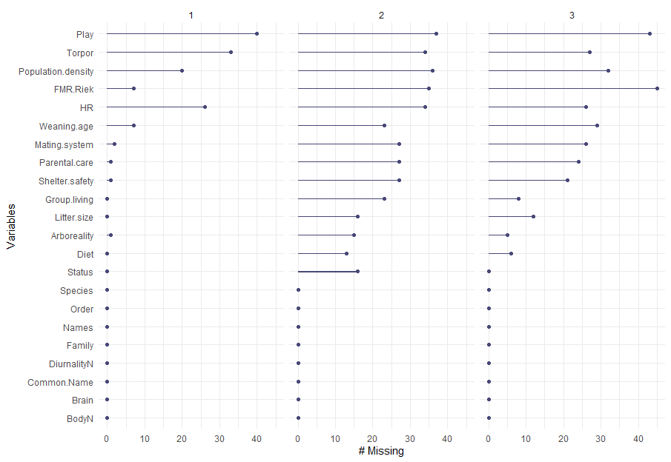

Figure 3. Number of missing data per geographic origin: 1 – Australia (n=90), 2 – New Guinea (n=40), 3 – Americas (n=45)

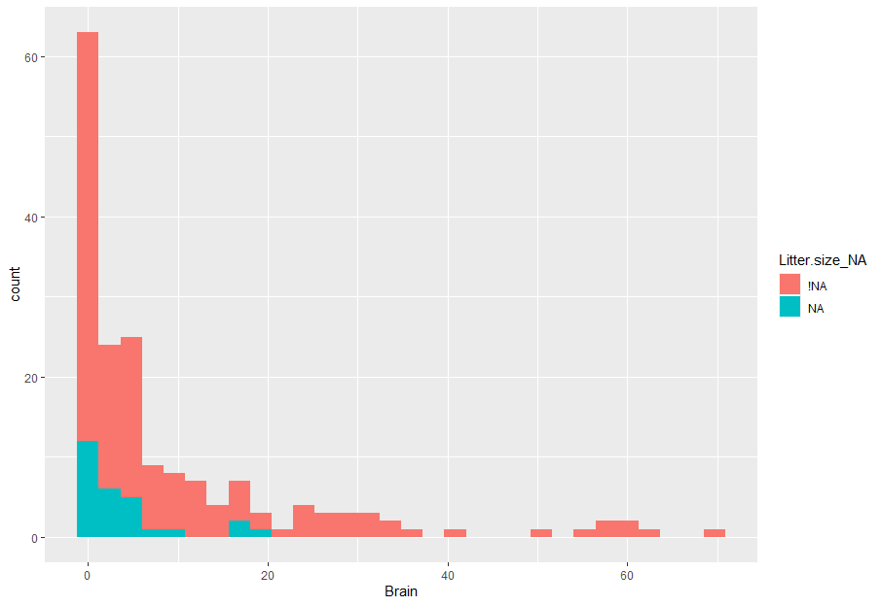

Figure 4a. Number of missing (NA) vs non-missing (!NA) data of litter size per different values of brain size. No variable showed any concerning pattern of missingness.

**Phylogenetic signal in missing data**

|  |  |  |  |  |  |
| --- | --- | --- | --- | --- | --- |
| Variable | N missing | N present | Estimated D | Probability of D random | Probability of D Brownian Motion |
| Status | 16 | 160 | 0.26 | 0 | 0.26 |
| Arboreality | 21 | 155 | 0.89 | 0.22 | 0 |
| Shelter safety | 49 | 127 | 0.52 | 0 | 0.01 |
| Diet | 19 | 157 | 0.65 | 0.01 | 0.02 |
| Group living | 31 | 145 | 0.59 | 0 | 0.01 |
| Parental care | 52 | 124 | 0.56 | 0 | 0.01 |
| Mating system | 55 | 121 | 0.45 | 0 | 0.03 |
| Litter size | 28 | 148 | 0.65 | 0 | 0 |
| Weaning age | 59 | 117 | 0.42 | 0 | 0.05 |
| Home range | 86 | 90 | 0.65 | 0 | 0 |
| Population density | 88 | 88 | 0.27 | 0 | 0.13 |
| FMR | 87 | 89 | 0.09 | 0 | 0.35 |
| Torpor | 94 | 82 | 0.66 | 0 | 0 |
| Play | 120 | 56 | 0.61 | 0 | 0 |

D is not significantly different from the Brownian motion expectation (D = 0) for most variables. FMR is nearest to a Brownian motion as some of the data in it is already based on imputations. Arboreality has the highest estimated D closest to random i.e. no phylogenetic signal. All other variables exhibit moderate phylogenetic signal.

*“D typically varies between 0 and 1. A D of 0 indicates that a trait evolves on a tree following the Brownian model (strong phylogenetic signal), and a D of 1 indicates that a trait evolves following a random model (no phylogenetic signal). D can be negative, which means that a trait evolves in a conserved way: more conserved than predicted by the Brownian model.”*

After inspecting all diagnostic plots included above, we proceed to multiple imputations.

**Evaluation**

Visual inspection and evaluation of ‘realistic’ imputation values of numerous species in all 25 imputed datasets was performed at random, and the imputed data seems to be realistic. Due to the nature of the missing data, many of the traits are difficult to compare with ‘realistic values’ (i.e. metabolic rate, play behavior). Due to the nature of multiple imputations, many values (including categorical variables) were different in different imputed datasets i.e. the same species was imputed as, for example, arboreal in one dataset, but as terrestrial in another.

**PGLS**

Table 1. Resume of PGLS models: DF – Degrees of freedom. Significant relationship between Origin 2 (New Guinea) (p=.007) and brain size, and interaction between vulnerability status 2 and body with brain size (p=.04)

|  |  |  |
| --- | --- | --- |
| Model | Significance | DF |
| Developmental | NS | 117 |
| Social | NS | 84 |
| Environmental | NS | 83 |
| Origin | Origin 2 (New Guinea)- p=.007 | 176 |
| Vulnerability status | Status2 (vulnerable):body size - p=.04 | 160 |
| Torpor | NS | 82 |
| Play | NS | 56 |
| FMR | NS | 89 |

**Detailed output of the PGLS models:**

*Significant predictors in bold*

DEVELOPMENTAL

Model: log(Brain) ~ log(BodyN) + Weaning.age + Litter.size

|  |  |  |  |  |
| --- | --- | --- | --- | --- |
|  | Value | Std.Error | t-value | p-value |
| (Intercept) | -2.0337675 | 0.25657510 | -7.926598 | 0.0000 |
| **log(BodyN)** | **0.5624441** | **0.01984942** | **28.335543** | **0.0000** |
| Weaning.age | 0.0000836 | 0.00015311 | 0.546064 | 0.5861 |
| Litter.size | -0.0281859 | 0.01648237 | -1.710062 | 0.0900 |

Residual standard error: 0.4491754

Degrees of freedom: 117 total; 113 residual

SOCIAL

Model: log(Brain) ~ Group.living + Parental.care + Mating.system + log(Population.density) + log(BodyN)

|  |  |  |  |  |
| --- | --- | --- | --- | --- |
|  | Value | Std.Error | t-value | p-value |
| (Intercept) | -2.1401495 | 0.3243932 | -6.597394 | 0.0000 |
| Group.living | -0.0194859 | 0.0543611 | -0.358452 | 0.7210 |
| Parental.care | -0.1395289 | 0.1544058 | -0.903650 | 0.3690 |
| Mating.system | 0.0207417 | 0.0621487 | 0.333744 | 0.7395 |
| log(Population.density) | 0.0166754 | 0.0174469 | 0.955779 | 0.3421 |
| **log(BodyN)** | **0.5911899** | **0.0241546** | **24.475225** | **0.0000** |

Residual standard error: 0.4904185

Degrees of freedom: 84 total; 78 residual

ENVIRONMENTAL

Model: log(Brain) ~ DiurnalityN + Shelter.safety + Arboreality + Diet + log(HR) + log(BodyN)

|  |  |  |  |  |
| --- | --- | --- | --- | --- |
|  | Value | Std.Error | t-value | p-value |
| (Intercept) | -1.9449889 | 0.29105712 | -6.682499 | 0.0000 |
| DiurnalityN | 0.0026436 | 0.02241524 | 0.117939 | 0.9064 |
| Shelter.safety | -0.0418645 | 0.04538671 | -0.922395 | 0.3592 |
| Arboreality | 0.0247103 | 0.07168543 | 0.344705 | 0.7313 |
| Diet | -0.0582259 | 0.03498454 | -1.664332 | 0.1002 |
| log(HR) | 0.0222148 | 0.01171517 | 1.896238 | 0.0617 |
| **log(BodyN)** | **0.5535672** | **0.02282740** | **24.250124** | **0.0000** |

Residual standard error: 0.4508372

Degrees of freedom: 83 total; 76 residual

ORIGIN

Model: log(Brain) ~ Origin * log(BodyN)

|  |  |  |  |  |
| --- | --- | --- | --- | --- |
|  | Value | Std.Error | t-value | p-value |
| (Intercept) | -2.2441539 | 0.2725458 | -8.23404 | 0.0000 |
| **Origin2** | **0.3297579** | **0.1223180** | **2.69591** | **0.0077** |
| Origin3 | 0.3332724 | 0.3502826 | 0.95144 | 0.3427 |
| **log(BodyN)** | **0.5684066** | **0.0169076** | **33.61846** | **0.0000** |
| Origin2:log(BodyN) | -0.0344183 | 0.0185696 | -1.85348 | 0.0655 |
| Origin3:log(BodyN) | -0.0434601 | 0.0427487 | -1.01664 | 0.3108 |

Residual standard error: 0.4532041

Degrees of freedom: 176 total; 170 residual

STATUS

Model: log(Brain) ~ Status * log(BodyN)

|  |  |  |  |  |
| --- | --- | --- | --- | --- |
|  | Value | Std.Error | t-value | p-value |
| (Intercept) | -1.9195140 | 0.23377689 | -8.210880 | 0.0000 |
| Status | -0.1425084 | 0.07412833 | -1.922456 | 0.0564 |
| **log(BodyN)** | **0.5345605** | **0.02036605** | **26.247626** | **0.0000** |
| **Status:log(BodyN)** | **0.0224436** | **0.01069771** | **2.097979** | **0.0375** |

Residual standard error: 0.4597327

Degrees of freedom: 160 total; 156 residual

TORPOR

Model: log(Brain) ~ Torpor * log(BodyN)

|  |  |  |  |  |
| --- | --- | --- | --- | --- |
|  | Value | Std.Error | t-value | p-value |
| (Intercept) | -2.2213566 | 0.26033158 | -8.532797 | 0.0000 |
| Torpor | -0.2348034 | 0.22461059 | -1.045380 | 0.2991 |
| **log(BodyN)** | **0.5812617** | **0.02597856** | **22.374668** | **0.0000** |
| Torpor:log(BodyN) | 0.0339674 | 0.03769176 | 0.901188 | 0.3703 |

Residual standard error: 0.3938022

Degrees of freedom: 82 total; 78 residual

PLAY

Model: log(Brain) ~ Play * log(BodyN)

|  |  |  |  |  |
| --- | --- | --- | --- | --- |
|  | Value | Std.Error | t-value | p-value |
| (Intercept) | -3.0915753 | 0.3485394 | -8.870089 | 0.0000 |
| Play | 0.2399924 | 0.1230628 | 1.950162 | 0.0566 |
| **log(BodyN)** | **0.6819123** | **0.0517292** | **13.182345** | **0.0000** |
| Play:log(BodyN) | -0.0280466 | 0.0199130 | -1.408457 | 0.1649 |

Residual standard error: 0.3412991

Degrees of freedom: 56 total; 52 residual

FMR

Model: log(Brain) ~ FMR.Riek * log(BodyN)

|  |  |  |  |  |
| --- | --- | --- | --- | --- |
|  | Value | Std.Error | t-value | p-value |
| (Intercept) | -2.3356588 | 0.3277660 | -7.125995 | 0.0000 |
| FMR.Riek | -0.0002394 | 0.0003741 | -0.639979 | 0.5239 |
| **log(BodyN)** | **0.5897278** | **0.0311626** | **18.924188** | **0.0000** |
| FMR.Riek:log(BodyN) | 0.0000213 | 0.0000339 | 0.627334 | 0.5321 |

Residual standard error: 0.4899207

Degrees of freedom: 89 total; 85 residual